**CENG 519 Term Project Phase 1 Report**

This report presents an analysis of the impact of randomly induced delays on the Round-Trip Time (RTT) and mean delay of network packets. The study utilizes a processor that adds random delays to Ethernet frames and measures the RTT using NATS messaging and Scapy packet processing.

* Packets are received via the NATS messaging system and processed with Scapy.
* A random delay is introduced before forwarding the packets to simulate middlebox processing effects.
* The RTT is calculated as the difference between the packet reception and forwarding times.
* Data is collected and visualized using Python and Matplotlib.

**Results**

* The Mean Delay for Packets graph shows variations in packet delays, with values mostly within microsecond ranges.
* The Average RTT for Packets plot demonstrates fluctuations in RTT values, indicating the effect of random delays.
* The Mean Delay vs. Average RTT scatter plot suggests a correlation between induced delay and RTT.

**Conclusion**

The introduction of random delays affects the RTT of network packets, as observed in the data. The results confirm that middlebox processing can introduce significant variations in packet transmission times.

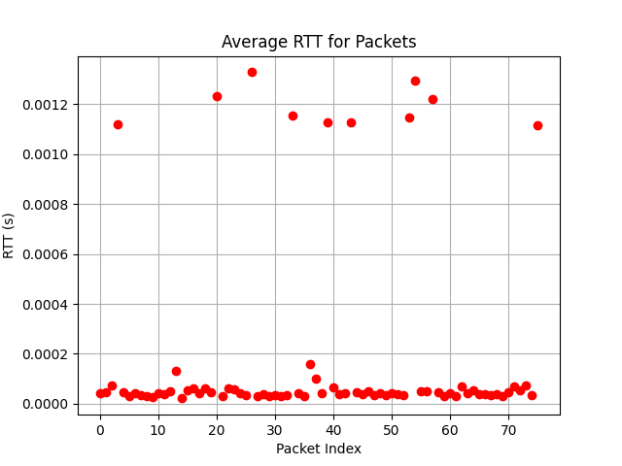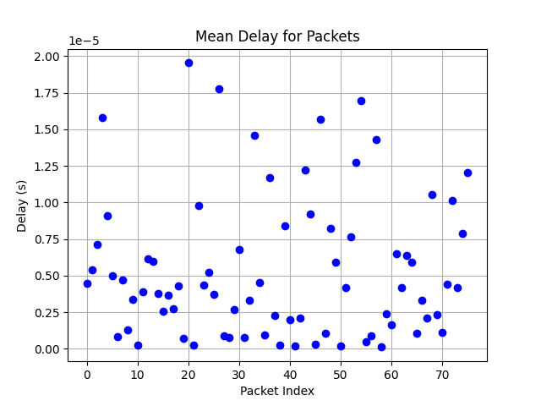

Melisa Nur Kart - 2237592